ENIGMA-Epilepsy: Brain volume comparisons between 963 epilepsy cases and 1,358 controls

Christopher D Whelan, Sophia Adams, Saud Alhusaini, Núria Bargalló, Emanuele Bartolini, Andrea Bernasconi, Boris Bernhardt, Karen Blackmon, Anna Calvo, Sarah Carr, Gianpiero L Cavalleri, Fernando Cendes, Antonio Cerasa, Andrea Cherubini, Luis Concha, Mark J Cook, Raul Cruces, Chantal Depondt, Patricia Desmond, Orrin Devinsky, Niels Föcke, Sonya Foley, Antonio Gambardella, Renzo Guerrini, Khalid Hamandi, Derrek P Hibar, Graeme Jackson, Neda Jahanshad, Reetta Kälviäinen, Simon S Keller, Raviteja Kotikalapudi, Patrick Kwan, Angelo Labate, Neda Ladbon-Bernasconi, Soenke Langner, Matteo Lenge, Kelly Leyden, Min Liu, Richard Q Loi, Mario Mascalchi, Carrie McDonald, Stefano Meletti, Laura Mirandola, Marcia Morita, Jillian Naylor, Terence O'Brien, Jose C Pariente, Yifan Ren, Mark Richardson, Andrea Ruggeri, Christian Rummel, Taavi Saavalainen, Margitta Seeck, Mira Semmelroch, Maria S Severino, Pasquale Striano, Thomas Thesen, Rhys Thomas, Manuela Tondelli, Manuela Tondelli, Domenica Tortora, Anna E Vaudano, Dennis Velakoulis, Lucy Vivash, Serge Vulliemoz, Bernd Weber, Roland Wiest, Clarissa Yasuda, Junsong Zhang, Paul M Thompson and Sanjay Sisodiya, for the ENIGMA-Epilepsy Working Group.

Introduction
Neuroimaging has improved our ability to detect neuroanatomical abnormalities associated with the pathophysiology and progression of epilepsy; however, the distinction between potentially epileptogenic and non-epileptogenic lesions remains unclear (Guerrini and Barba, 2010; Engel et al., 2013). We formed the ENIGMA-Epilepsy Working Group to identify reliable imaging biomarkers for epilepsy, quantify differences in syndromic diagnoses, and explore the effects of epilepsy chronicity and other sources of heterogeneity. Here we present findings from our preliminary investigation of volume differences between people with epilepsy and healthy controls across 84 bilateral regions of interest (ROI).

Methods
Structural T1-weighted MRI scans were analyzed locally at 16 sites worldwide using FreeSurfer (Fischl, 2012) and a set of standardized ENIGMA quality control protocols (see http://enigma.ini.usc.edu/protocols/imaging-protocols/). Epilepsy cases were stratified into four subgroups: (1) all non-lesional cases with a syndromic diagnosis of epilepsy (N=963), (2) genetic generalized epilepsies (GGE; total N=230), (3) temporal lobe epilepsies with mesial temporal sclerosis (TLE-MTS) of the left hemisphere (total N=288) and (4) TLE with MTS of the right hemisphere (total N=257). The average age of the full epilepsy cohort (N=963) was 33.35 years, with an age range of 18-55 years. 59% of cases were female. Participants with a history of neurosurgery, focal cortical dysplasias or tumors were excluded from the study.

Each patient subgroup was compared to a cohort of neurologically healthy controls (total N=1,358; mean age: 33.35 years; age range: 18-55 years; 54% female) using the R linear model function, lm, controlling for age, sex and intracranial volume (ICV). Group contrast effect sizes, generated locally at each ENIGMA site, were imported into the metafor package (Viechtbauer, 2010) and subjected to a random-effects meta-regression. We declared any volume differences significant if they exceeded a Bonferroni-corrected level of p<5.95x10⁻⁴.

Results
Compared to healthy controls, the ‘all non-lesional epilepsies’ subgroup showed subcortical volume loss in the thalamus (right hemisphere; RH; d=-0.39) and pallidum (RH; d=-0.33), as well as broad patterns of cortical thinning in the precentral gyrus (BL; d<-0.39), paracentral gyrus (RH; d=-0.35), caudal middle frontal gyrus (bilateral; BL; d<-0.3) and superior parietal gyrus (RH; d=-0.27). The GGE subgroup showed significant volume reductions in the caudate (left hemisphere; LH; d=-0.3) and precentral gyrus (BL; d<-0.33). The left TLE-MTS subgroup had smaller hippocampus (LH; d=-1.7), thalamus (BL; d<-0.52), pallidum (RH; d=-0.51), precentral gyrus (BL; d=-0.5), paracentral gyrus (RH; d=-0.47), precuneus (RH; d=-0.42), caudal middle frontal gyrus (BL; d=-0.42) and superior frontal gyrus (LH; d=-0.38) volumes. The right TLE-MTS subgroup had smaller hippocampus (RH; d=-1.97), thalamus (RH; d=-0.81), pallidum (RH; d=-0.38), precentral gyrus (BL; d=-0.48), paracentral gyrus (BL; d=-0.4) and caudal middle frontal gyrus (LH; d=-0.39) volumes.

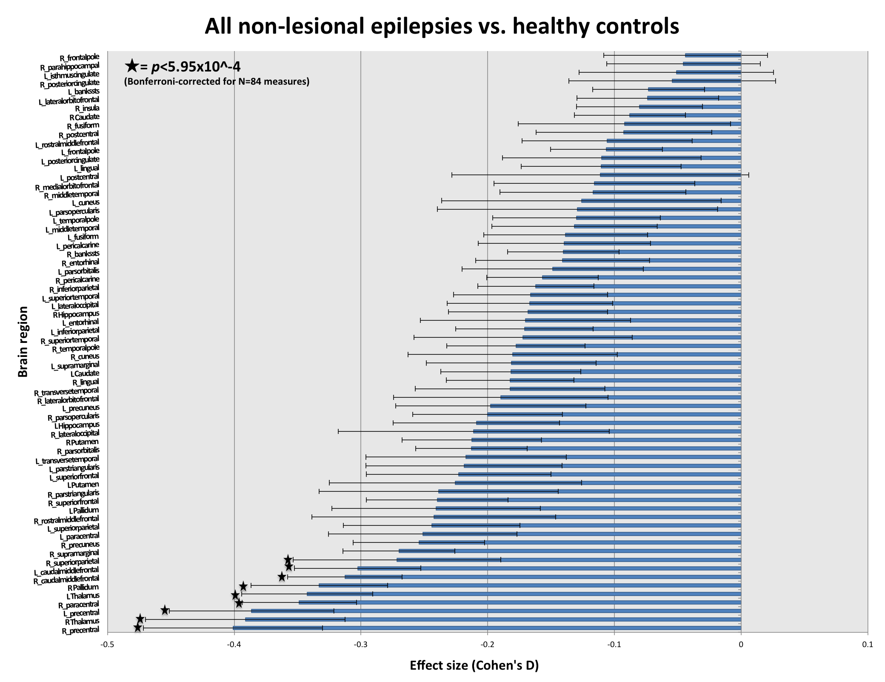
Figure 1: Effect sizes for regional brain volume differences between non-lesional epilepsy patients (N=963) and healthy controls (N=1358)

Discussion
This prospective meta-analysis of neuroimaging data by the ENIGMA-Epilepsy Working Group indicates distinct patterns of volume loss across four major epilepsy subtypes. First, a heterogeneous group of epilepsy cases without prior evidence of clinical MRI abnormalities showed significant atrophy in the motor cortex and parts of the forebrain. A similar (albeit attenuated) pattern of subcortical and cortical thinning was observed in a smaller subsample of GGE cases. TLE-MTS patients showed profound volume loss in the ipsilateral hippocampus, as well as extrahippocampal regions including the basal ganglia, motor cortex and parts of the frontal lobe. Future meta-analyses will explore factors that may modulate these structural alterations (including epilepsy chronicity) in a network that has grown to 23 centers worldwide.

References
Engel J Jr, Pitkänen A, Loeb JA, Dudek FE, Bertram EH 3rd, Cole AJ, Moshé SL, Wiebe S, Jensen FE, Mody A, Nehlig I, Vezzani A. (2013). Epilepsy biomarkers. Epilepsia s4:61-9.

Fischl B. (2012). FreeSurfer. NeuroImage 62(2): 774-81.

Guerrini R, Barba C. Malformations of cortical development and aberrant cortical networks: epileptogenesis and functional organization. J Clin Neurophysiol. 27:372-379.

Viechtbauer W. (2010). Conducting meta-analysis in R with the metafor package. Journal of Statistical Software 36(3):1-48.

CHARACTER COUNTS:
Title character limit: 100 | Title character count for our abstract: 88
Abstract character limit: 4000 (with spaces) | Character count for our abstract: 3,983
Figures limit: 4 | Number of figures for our abstract: 4
References limit: 10 | Number of references in our abstract: 4

